Ian Kilgore

11/14/2017

Locating an Earthquake

Problem:

How can you determine the location of an earthquakes epicenter?

Materials:

* Earth science textbook
* Pencil
* Drawing compass
* World map
* Computer with Internet access

Procedures:

1. Using the three seismograms in the textbooks that show earthquake activity in New York City, Seattle, and Mexico City, use the time-travel graph to figure out the distance of the city from the epicenter and record the answers in the data table.
2. Using a world map, mark the three cities clearly on the map.
3. Using a drawing compass make a circle around the three cities. The radius f the circle should be equal to the city’s distance from the epicenter. You would use the scale on the textbook map to set the distance for your compass.
4. Using a computer with internet access search for ten recent earthquakes and make a table, which shows the location, date and magnitude of each earthquake.

Data table:

|  |  |  |  |
| --- | --- | --- | --- |
|  | New York City | Seattle | Mexico City |
| Elapsed time between first P and first S waves | 4 min | 3 min | 2 min |
| Distance from epicenter in miles | 1500 miles | 820 miles | 610 miles |
| Distance from epicenter in kilometers | 2450 km | 1300 km | 975 km |

|  |  |  |
| --- | --- | --- |
| Recent Earthquake  Location | Date | Magnitude |
| Halabja, Iraq | 11/12/2017 | 7.3 |
| Guadalcanal, Solomon Islands | 11/16/2017 | 5.6 |
| Taveuni Island, Fiji | 11/14/2017 | 5.5 |
| Mare, New Caledonia | 11/16/2017 | 5.5 |
| Santa Rita, Guam | 11/14/2017 | 5.8 |
| Tokyo, Japan | 11/16/2017 | 5.8 |
| Soledad, California | 11/13/2017 | 4.6 |
| Pohang-si, Gyeongsangbukdo, South Korea | 11/14/2017 | 5.4 |
| Puntarenas Province, Parrita, Costa Rica | 11/12/2017 | 6.5 |
| Kesennuma, Miyagi Prefecture, Japan | 11/12/2017 | 5.8 |

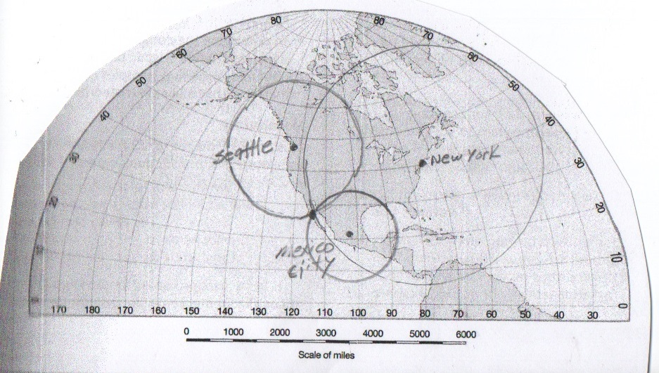

Conclusions:

After drawing the circles around the cities that show the distance in miles from the epicenter, we can see the three circles intersect and the epicenter is approximately 27**°** N and 114**°** W.